CAYUSE

TUTORIAL human ethics
  - SLUHN IRB
Prepared by Maria T. Martinez-Baladejo

TABLE OF CONTENTS
What Is Cayuse? 3
I. What Features Are Available In The SLUHN Cayuse System? 4
II. How To Create Your Account 6
III. Accessing And Using The Cayuse Help Center? 7
IV. Useful Links 10
V. SLUHN Cayuse Forms and Instructions 11
VI. Responding To IRB Comments 29
VII. How To Certify a Submission 33
Appendix 36
Complete Initial Form 36
Complete Periodic Review Form 56
Complete Modification Form 62
Complete Incident (UAP or SAE) 65
Complete Withdrawal 70
Complete Final Report 71

What Is Cayuse?
As of June 2023, St. Luke’s University Health Network (SLUHN) will be transitioning to an all web-based system. Cayuse IRB is a web-based platform designed to streamline the process of submitting and managing Institutional Review Board (IRB) protocols for research studies. It is commonly used by universities, research institutions, and other organizations that conduct human subjects research. It is used at institutions such as The Ohio State University, UC Berkley, Duke University, St. Jude Children’s Hospital, Chapman University, among others.

The Cayuse IRB platform provides researchers with a centralized system for creating, submitting, and tracking IRB protocols. It offers various features and tools to facilitate the IRB review process, including electronic forms, document management, and communication tools.

Here are some key features and functionalities of the Cayuse IRB platform:

- Online Submission: Once the protocol and associated documents are complete, researchers can submit their IRB applications online through the Cayuse IRB platform. The system guides users through the submission process, ensuring that all required information is provided.
- Review Process: The platform facilitates the review process by allowing IRB members to access and evaluate submitted protocols online. Reviewers can add comments, request modifications, or approve protocols directly within the system. The platform offers features for tracking the status of reviews and sending automated notifications to researchers.
- Collaboration and Communication: Cayuse IRB provides communication tools to facilitate collaboration among researchers and the IRB office.
- Compliance Tracking: The platform helps researchers and institutions stay compliant with relevant regulations and policies by tracking important dates, such as protocol expiration and renewal deadlines. It also generates reports and reminders to assist with compliance management.

To reach the Cayuse Log-In Page, please type in the following link into your browser:
https://sluhn.app.cayuse.com/
For questions/comments about Cayuse, please contact the IRB office.

What Features Are Available In The SLUHN Cayuse System?
Please note that we will be updating our IRB forms and titles to adapt to the new IRB system. See the titles and descriptions for each of the forms below:

INITIAL | DESCRIPTION
Previously known as IRB Initial Application | For Full Board Review Submissions
 | For Expedited Review Submissions (includes Waiver of HIPAA Authorization section)
 | For Exempt Review Submissions (includes Waiver of HIPAA Authorization section)
 | For Clinical Use of Humanitarian Use Device Submissions
 | For Expanded Access Program/Compassionate or Emergency Use Review Submission

modification | DESCRIPTION
Previously known as IRB Amendment Form | For Full Board / Expedited / Exempt Review Amendments/Adding & Removing Investigators

RENEWAL | DESCRIPTION
Previously known as Periodic Review Form | For Full Board / Expedited
 | For Clinical Use of a Humanitarian Use Device Renewals
 | For Expanded Access Program

INCIDENT | DESCRIPTION
IRB SAE Report Form | Expedited Review Serious Adverse Event Reports
IRB UAP Report Form | Expedited Unanticipated Problem Reports

CLOSURE | DESCRIPTION
IRB Final Report Form or Withdrawal Form | Expedited Review Closures

How To Create Your Account
To create an account with Cayuse, you will need to follow the registration process.
Please complete the following information and forward your request to: jayne.silva@sluhn.org
Please note in your email what your current title is at St. Luke’s Health Network.
First Name:
(Middle Name):
Last Name:
SLUHN User Principal Name (UPN): (typically your email, if not known check your workday account)
Employee ID: (if no known check your workday account)
Department:
Title:
Phone:
Email:
Please allow 48 hours for your account to be created. Once your account has been created, someone from the IRB Team will e-mail you a confirmation.
Should you have any questions, please feel free to contact the Cayuse team at jayne.silva@sluhn.org

Accessing And Using The Cayuse Help Center?
There are several ways to access the Cayuse Help Center. Direct access and access through the Cayuse Application are described below.
Note: When accessing the Help Center for the first time, you will be required to create a new account separate from the Cayuse platform.

Option 1: Access the Cayuse Help Center Directly
- Open the Cayuse Help Center sign-in page.

Option 2: Access Cayuse Help Center from Cayuse Application
1. Log into the Cayuse Application using your SLUHN-Cayuse username and password.
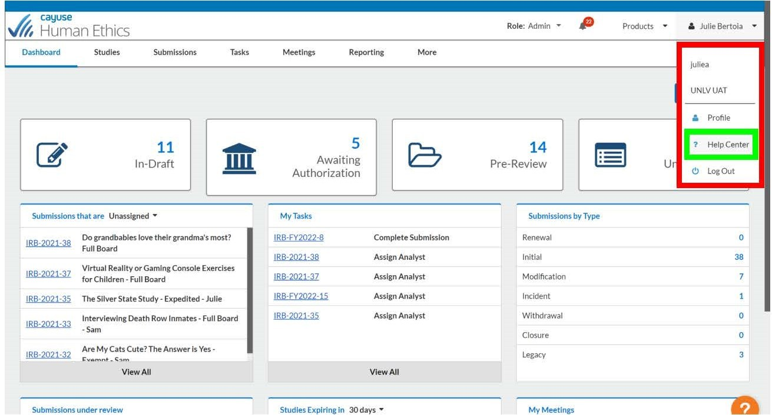
2. Click on your name in the top right-hand corner and select “Help Center”.

B. Using the Cayuse Help Center Webpage
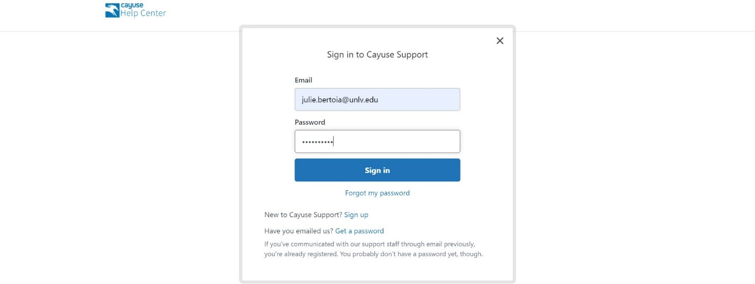
1. Enter the email used with Cayuse Help Center and password to sign in.
If it’s your first time using the Cayuse Help Center, click on the “Sign up” link and enter your name and email address. You will receive an email from Cayuse with a temporary password to access the Cayuse Help Center and from there you can update your password.
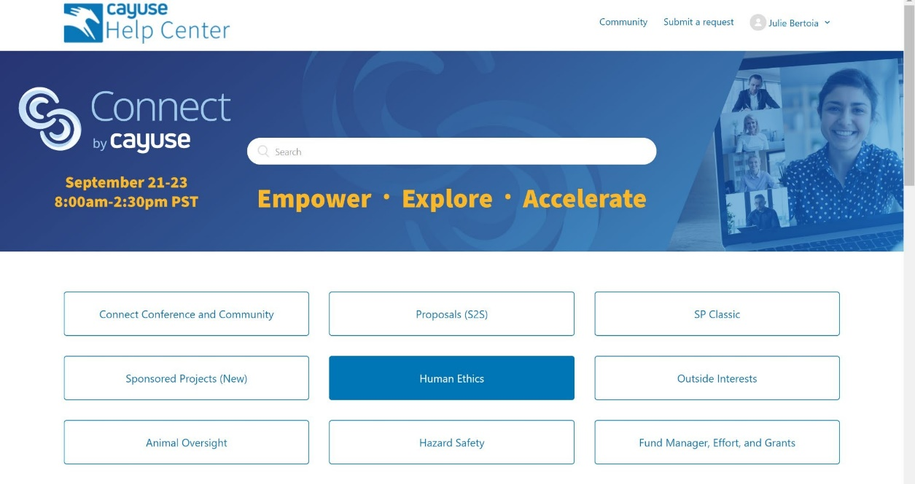
- From the Cayuse Help Center landing page, select “Human Ethics”.
- Navigate to the desired category for help.
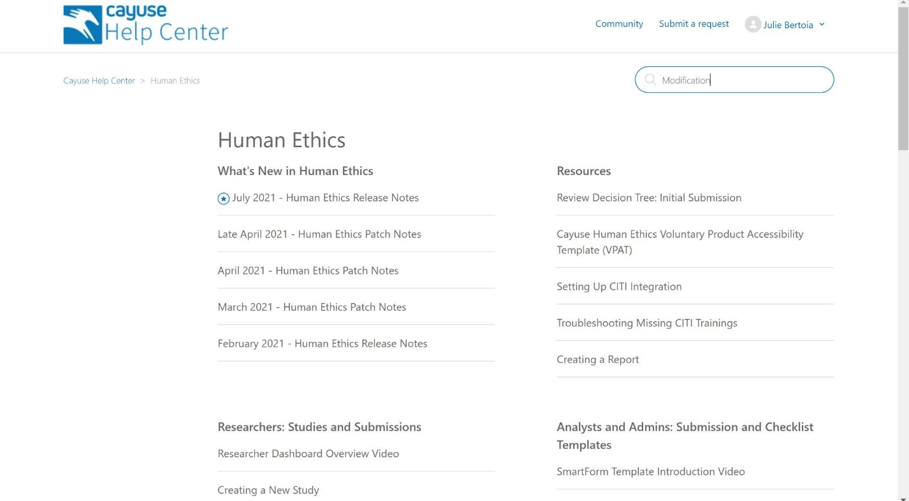

Alternatively, type in a keyword into the search box, such as “Modification” to view all articles related to that keyword.
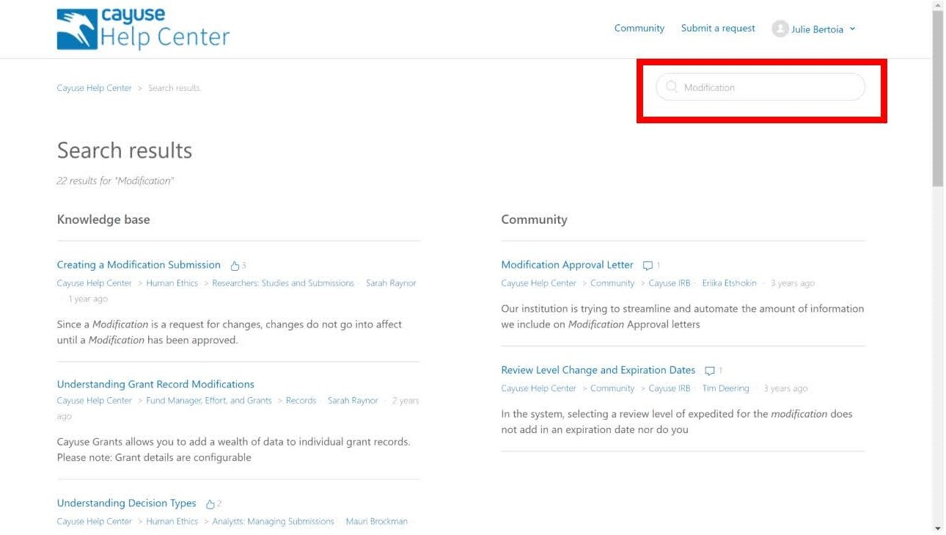

Useful Links
Kindly be aware that the information provided in these links may differ depending on the institution. To obtain information about SLUHN forms, please proceed with reading this tutorial.
In order to access the links, it is necessary to have already created an account in the Cayuse Help Center.

- How do I create a new study?
- How do I complete a submission?
- How do I create an initial submission?
- Dashboard overview video.
- What submission types are available in the system?
- What are the different types of IRB decision in the system?

Please keep in mind that in order to submit your study for review, it is essential to have your CITI trainings (good clinical practice [GCP] and human subject research [HSR]), FCOI form, and FCOI training current and up to date.

SLUHN Cayuse Forms and Instructions
In an effort to simplify the process, we have included instructions and supplementary information that will assist you throughout the applications. Please note the question marks at the top right of the questions, as they provide additional information.
Please consult the appendix section to access a comprehensive list of all forms and their respective questions.
General Rules
- Radio buttons will allow you to select only one answer. A red star next to the questions indicates that the question is mandatory and must be answered.
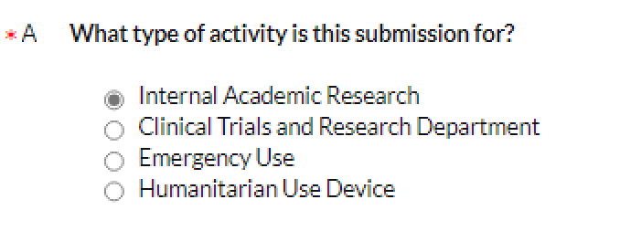
- Square buttons allow you to select multiple answers.
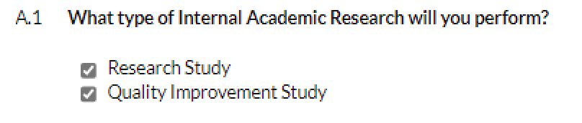
- Based on your answers, the system will dynamically generate additional questions or tabs. This feature enables you to bypass questions that are not relevant to your study, resulting in a streamlined process.
- If a question is not applicable to your study, please choose the option “does not apply” or simply write “does not apply” in the text box.

- Creating a Study
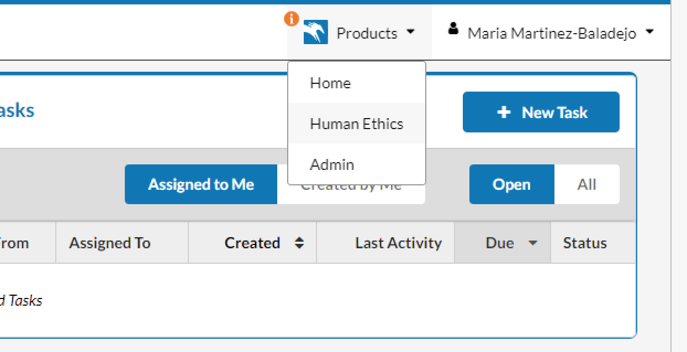
  - Sign into your account and select “Human Ethics.”

  - Select “Studies.”
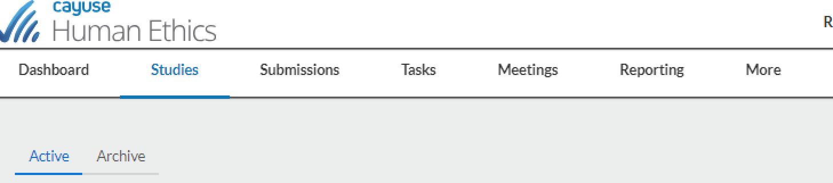
  - Click on “New Study.”
  - Name your study on the available box and hit the check mark.

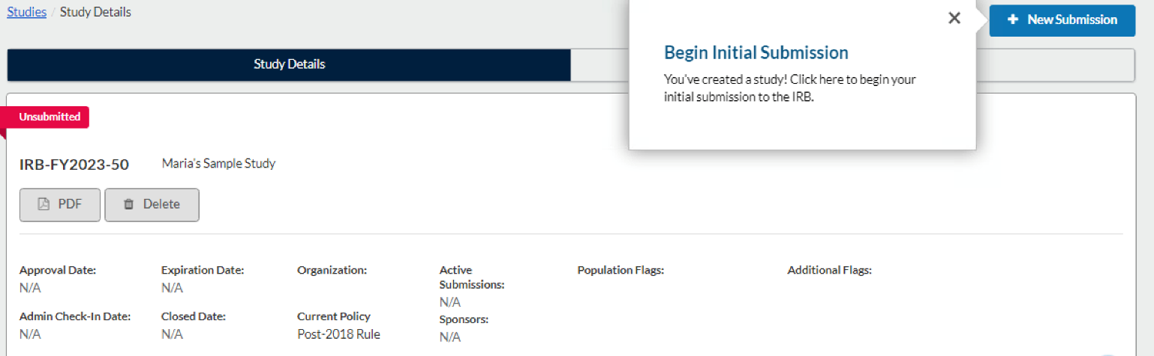
  - Once your new study has been created, you will be prompted to start an initial submission.

- Initial Form
Prior to starting an initial form, you will need to create a study, see the steps in section A.
- Click on “+New Submission” and click on “Initial.”
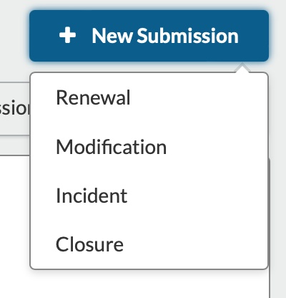
- Under required tasks, click on “Complete Submission.”
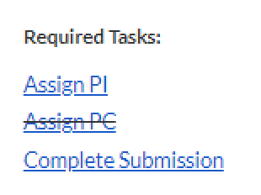
- Read tab #1 titled “Getting Started” and make sure that you are ready to start your submission. Click “yes” if you are ready, this will populate tabs two and three.
- On the second tab labeled "Submission Information," you are required to select the type of submission you will be making. Upon making your selection, various tabs will automatically appear based on your chosen submission type. Continue to answer the remaining questions as they pertain to your study.
- Please consult the appendix section to access a comprehensive list of all forms and their respective questions.
- Make sure that all the required questions are answered to be able to submit your initial form.
- If a question is not applicable to your study, please choose the option “does not apply” or simply write “does not apply” in the text box.
- Route your study for PI certification and hit “Complete Submission.”
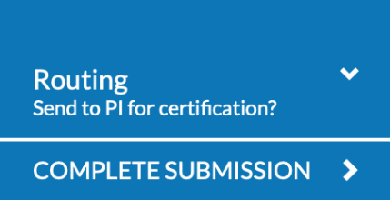
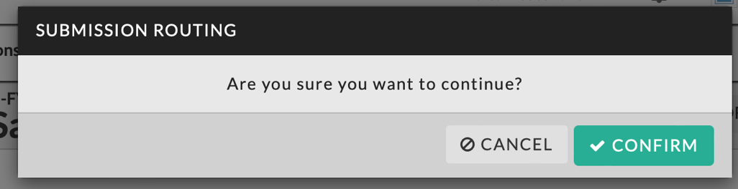
- The PI will get a notification under the bell and through email.
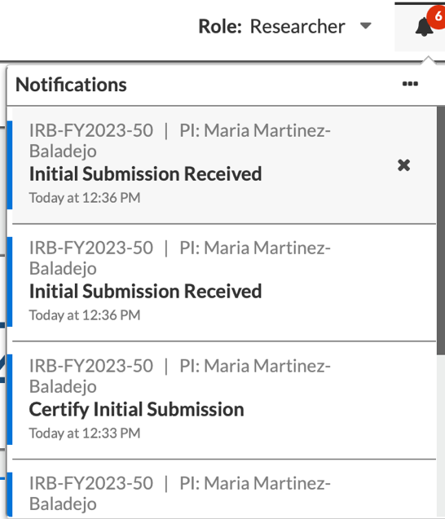

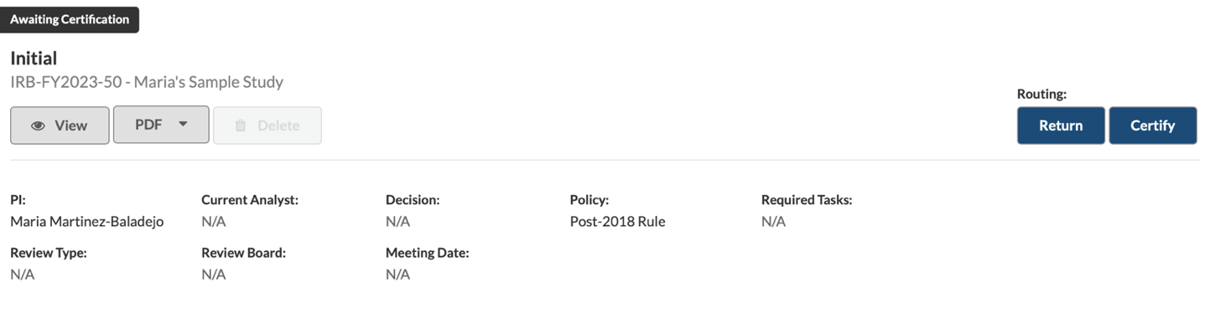
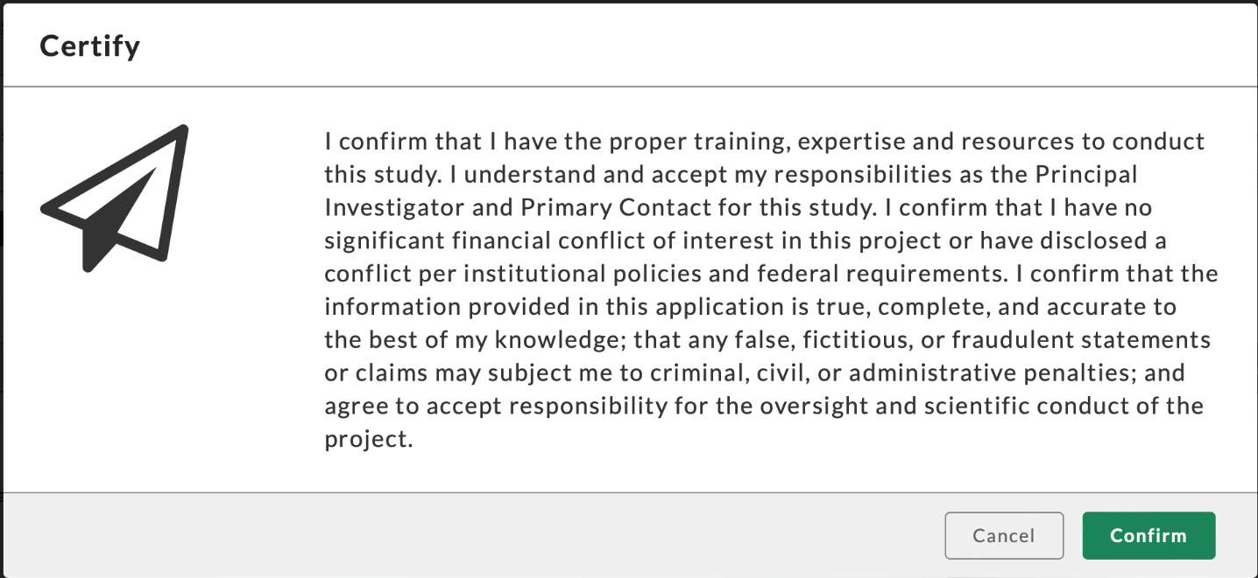
- The PI must certify the study before it shows in the IRB task center. Select “Certify” and then “Confirm.” For a comprehensive guide on how to certify a submission refer to section VII (How to Certify a Submission).

- Once the PI certifies the study, it will be listed as a pre-review. At this stage, you can access the study in view mode or generate a PDF version of your submission. Please note that no modifications can be made at this time. If you wish to retract your study before IRB approval you can submit a “Withdrawal” form.
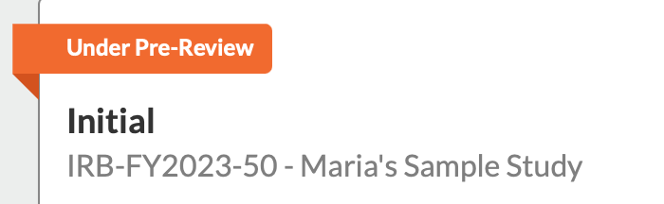

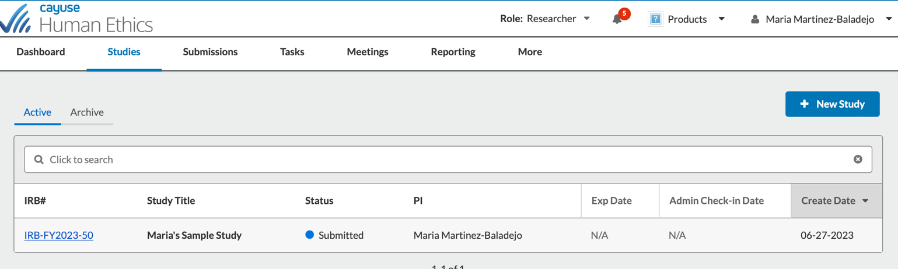
- Now the study will be visible under the “Studies” tab.

- Once the PI certifies the study, the person that submitted the application and the PI will receive an email confirming that the study is under review (see below).
INSTITUTIONAL REVIEW BOARD
TO: Investigator
Department of Research and Innovation
FROM: Office of Human Research Protections

DATE: Jun 28, 2023 12:36:42 PM EDT

RE: Notice of Receipt of Initial Submission on Jun 28, 2023 12:36:42 PM EDT

STUDY #: IRB-FY2023-50

STUDY TITLE: Sample Study

Your IRB submission for the above-referenced study has been received by the Institutional Review Board/Human Research Protections Office. You will be notified if further information is needed and when this has been reviewed and approved.

Thank you,
Human Research Protections Office
St Luke's University Health Network

- Renewal Form
Upon approaching one year of study approval, you will receive an email notification prompting you to renew the IRB approval of your submission.
- Access your Cayuse profile and locate the notification bell icon to initiate the process. Click on the renewal form notification that corresponds to the relevant study.
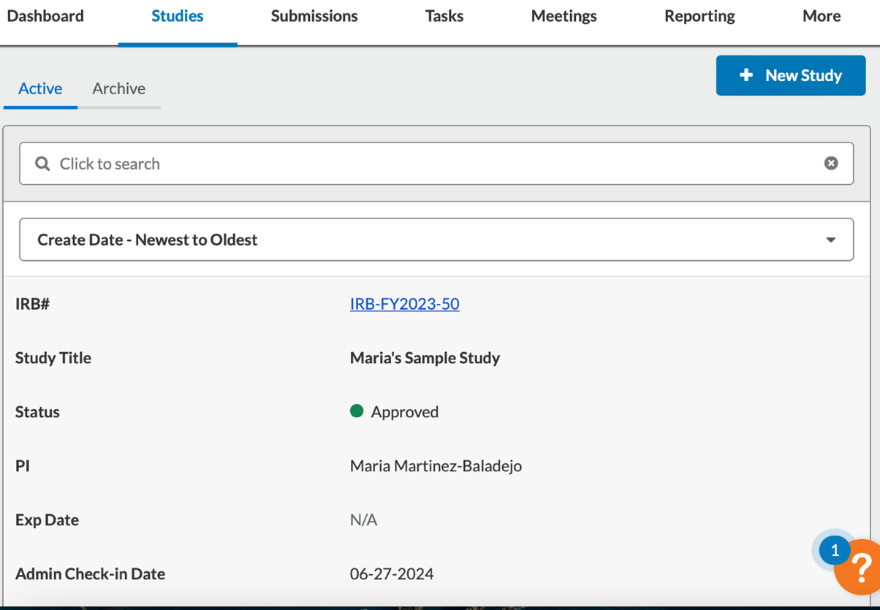
- Or click on “Studies” and select your study.
- In the study page identify +New Submission button and select “Renew.”
- Select “Complete Submission.”
- On the initial page of this form, you will find instructions and helpful information to ensure your submission is prepared appropriately. See the appendix for more information. Read the information and select yes if you are ready to start this form.
- Answer the questions appropriately. Once you have made your selection, tabs specific to your submission type will be automatically displayed. Proceed to answer the remaining questions that are relevant to your study.
- Please consult the appendix section to access a comprehensive list of all forms and their respective questions.
- If a question is not applicable to your study, please choose the option “does not apply” or simply write “does not apply” in the text box.
- To submit your form, follow the instructions for submission and certification of submission stated in section B (Initial Form) and VII (How to Certify a Submission).

- Modification Form
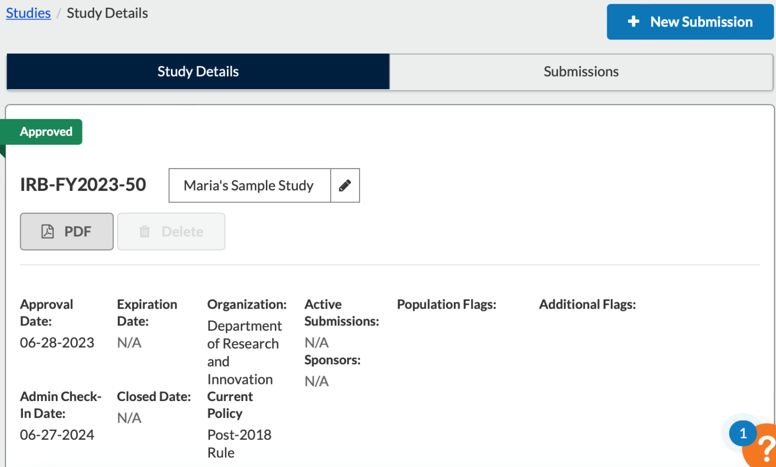
- Click on “Studies” and select your study.

- In the study page identify +New Submission button and select “Modification.”
- Select “Complete Submission.”
- Please be aware that this form will open your original submission. Take the time to review your previous answers and make any necessary updates. The IRB committee will be able to see the changes that you have made to your submission.
- Once you have made your selection, tabs specific to your submission type will automatically bet displayed. Proceed to answer the remaining questions that are relevant to your study.
- To access a comprehensive list of all forms and their respective questions, please consult the appendix section.
- If a question is not applicable to your study, please choose the option “does not apply” or simply write “does not apply” in the text box.
- To submit your form, follow the instructions for submission and certification of submission stated in section B (Initial Form) and VII (How to Certify a Submission).

- Incident Form
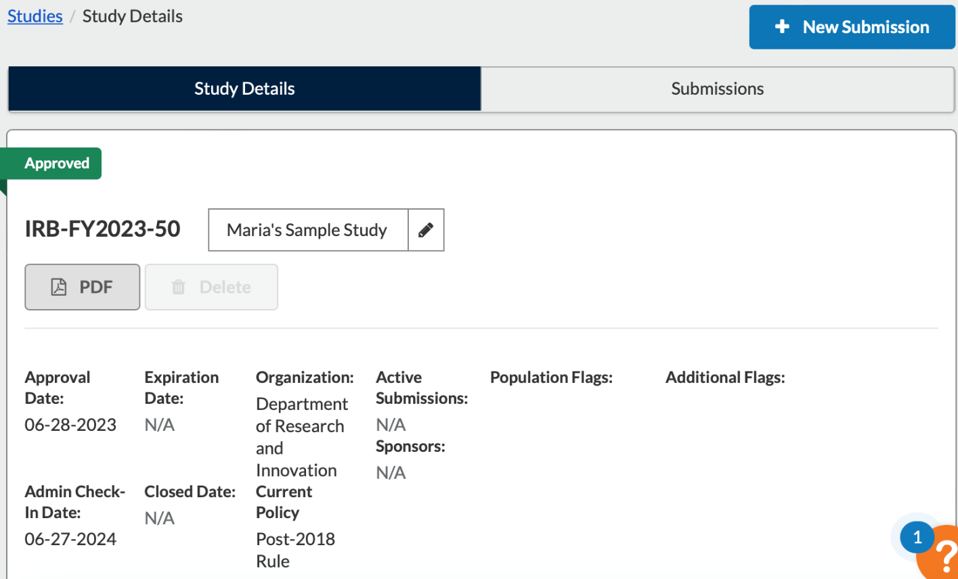
- Click on “Studies” and select your study.

- In the study page identify +New Submission button and select “Incident.”
- Select “Complete Submission.”
- Read tab #1 titled “Instructions” and make sure that you are ready to start your submission. Click yes if you are ready, this will populate tab two.
- Answer the questions appropriately. Once you have made your selection, tabs specific to your submission type will automatically be displayed. Proceed to answer the remaining questions that are relevant to your study.
- To access a comprehensive list of all forms and their respective questions, please consult the appendix section.
- If a question is not applicable to your study, please choose the option “does not apply” or simply write “does not apply” in the text box.
- To submit your form, follow the instructions for submission and certification of submission stated in section B (Initial Form) and VII (How to Certify a Submission).

- Closure Form
- Click on “Studies” and select your study.

- In the study page identify +New Submission button and select “Closure.”
- Select “Complete Submission.”
- Read tab #1 titled “Getting Started” and make sure that you are ready to start your submission. Click yes if you are ready, this will populate tab two.
- Answer the questions appropriately. Once you have made your selection, tabs specific to your submission type will automatically be displayed. Proceed to answer the remaining questions that are relevant to your study.
- Please consult the appendix section to access a comprehensive list of all forms and their respective questions.
- If a question is not applicable to your study, please choose the option “does not apply” or simply write “does not apply” in the text box.
- To submit your form, follow the instructions for submission and certification of submission stated in section B (Initial Form) and VII (How to Certify a Submission).

Sample Acknowledgement email:
Date: 06/30/2023
PI: PI Name
Department: Department of Research and Innovation
Re: Incident - IRB-FY2023-50
Sample Study
The St Luke's University Health Network - UAT/Training Tenant Institutional Review Board has acknowledged the reported unanticipated problem.
This approval is based on the understanding that you will:
- Immediately inform the IRB of all patients' adverse events and any changes in procedures and project status changes that may occur after this review.
- Agree to comply with FDA, OPRR, and St Luke's University Health Network IRB regulations.
- Allow the review of research project records by the IRB as requested.
Any modifications to the approved study must be submitted for review through Cayuse IRB. All approval letters and study documents are located within the Study Details in Cayuse IRB.
St. Luke's University Health Network has a Federal Wide Assurance [FWA 00003557] from OHRP. The Institutional Review Board is registered with OHRP [IRB 00002757] and is in compliance with 45 CFR 46, 21 CFR 50 and 21 CFR 56. To the extent these Federal regulations are in agreement with the ICH Guidelines, we are also in GCP compliance.
Please feel free to contact us at 610-776-4832 if you have any questions regarding this or other IRB items.

Sincerely,
Chair
St Luke's University Health Network - UAT/Training Tenant Institutional Review Board

- Withdrawal Form
If you wish to retract a study that has been previously submitted to the IRB and is currently undergoing review, you can utilize a straightforward form designed for withdrawal. This form enables you to retract your application prior to receiving approval from the IRB. Once a study has obtained IRB approval, the procedure to follow involves submitting a closure form.
Note: This form is exclusively accessible for initial forms that have been submitted to the IRB but that have not yet been IRB approved.
- To begin, locate your study and choose the option "+New Submission." From there, select the "Withdrawal" option.
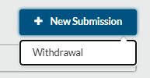
- Upon clicking the withdrawal option, the system will display a message to confirm your intent to withdraw the submission. Click the "confirm" button, and then proceed by selecting "Complete Submission."
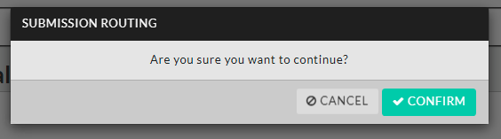
- Complete the withdrawal request form and then choose the "Complete Submission" option.
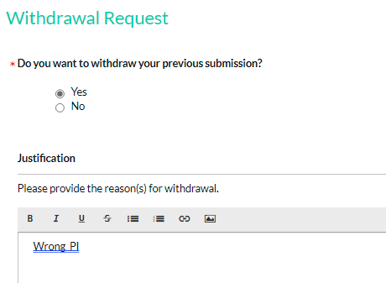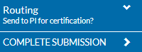

- After choosing "Complete Submission," the system will reconfirm your decision to withdraw the form. Proceed by selecting the "Withdraw" option.
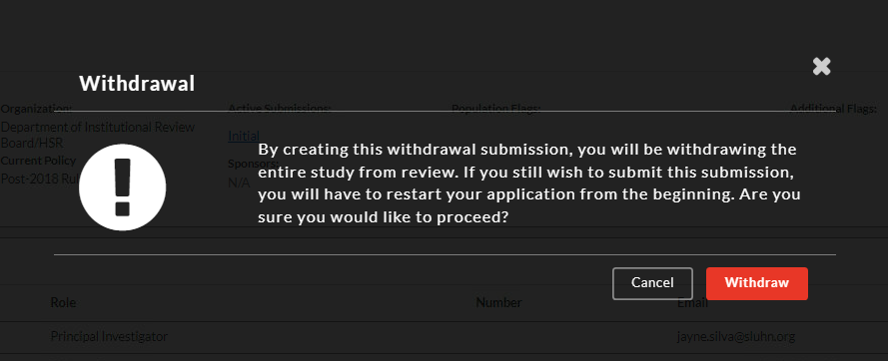

- Subsequently, the study will be directed to the Principal Investigator (PI) for their certification regarding the withdrawal. Follow the steps outlined for certifying a study. Both you and the PI will receive an email confirmation of the withdrawal.

Responding To IRB Comments
After the IRB reviews your study, you will receive an email notification indicating either the approval of your study by the IRB or detailing the need for further modifications. To respond to IRB comments please see the steps below.
Sample Email:
INSTITUTIONAL REVIEW BOARD
TO: Investigators
FROM: Office of Human Research Protections

RE: Initial Submission Returned to Investigators

STUDY #: IRB-FY2024-20
STUDY TITLE: Sample Study
The Office of Human Research Protections has completed their review and returned the above referenced study in Cayuse IRB to the investigators for changes. Please log into Cayuse IRB to review the requested changes, make the appropriate revisions within the submission, respond to all comments, and provide updated versions of any revised study attachments, as applicable.
Thank you in advance for your prompt response. Please contact the IRB staff if you have any questions or concerns.
Thank you,
Human Research Protections Office
St Luke's University Health Network

  - Sign into your account and select “Human Ethics.”
  - On your dashboard under your tasks select the study of interest.
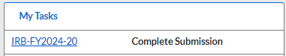
  - You will observe that your study has been labeled as "Reopened." This signifies that your study requires additional modifications, or the IRB has inquiries regarding your study.
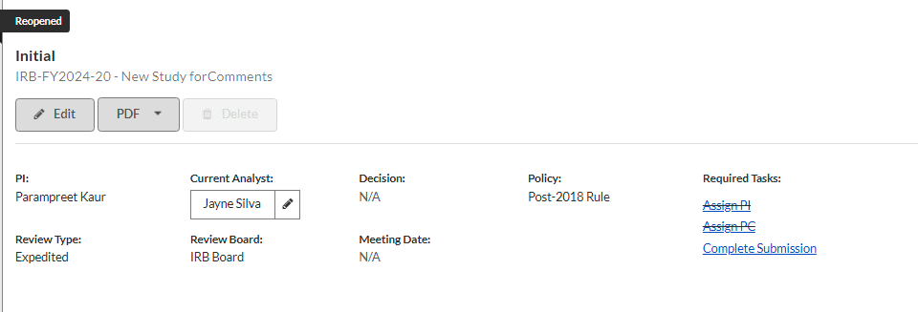
  - Select “Complete Submission.”
  - Once inside the study submission, you will see where the IRB has added comments to your study.
  - Click on the tab that needs further revision and select “Expand Comments” to see the IRB recommendations or questions.
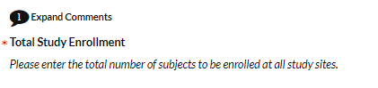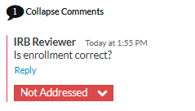
  - Click on “Reply” to reply to the IRB comments or questions. Once, you have added your comments, select “Not Addressed” and select “Address.”
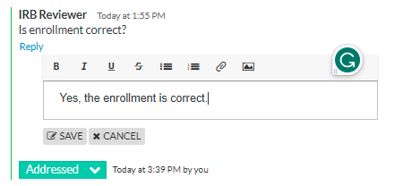
  - After addressing all comments and questions appropriately, you can proceed to follow the outlined steps on the initial form to submit your study. To see the process of the PI certifying the study, please refer to the "how to certify a submission" in section VII.

How To Certify a Submission

  - Sign into your account and select “Human Ethics.”

  - To certify the initial submission, click on the notification bell and choose the option “Certify Initial Submission.” Alternatively, you can select the blue number code associated with the submission under your tasks, labeled as “Certify Submission.”
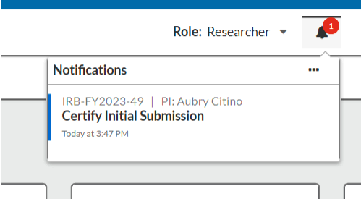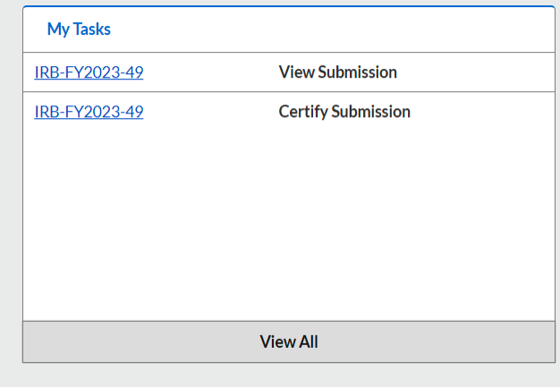

  - When the initial submission is made, it will be marked as “Awaiting Certification,” and you will have the option to view it. Once you have reviewed the submission, you will need to return to your dashboard, follow steps 1-2 again, and click on “Certify.” If you identify any areas that need changes after the review, you can select “Return” to send the form back to the creator.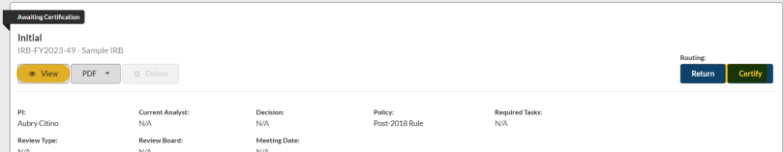

  - Click “Confirm.”
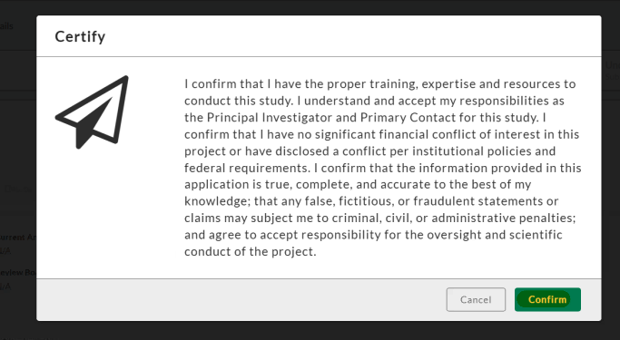

Appendix

Complete Initial Form
Kindly be aware that the questions displayed will vary based on the answers you provide in the system. Therefore, not all questions listed below may be applicable to you specific study.

1-Getting Started
About Cayuse IRB
Cayuse IRB is an interactive web application. As you answer questions, new sections relevant to the type of research being conducted will appear on the left-hand side. Therefore not all numbered sections may appear. You do not have to finish the application in one sitting. All information can be saved.

Additional information has been added throughout the form for guidance and clarity. That additional information can be found by clicking the question mark it the top-right corner of each section.

For more information about the IRB submission Process, IRB Tracking, and Cayuse IRB Tasks, please refer to the Cayuse IRB Procedures Manual.

For more information about St. Luke's Health Network IRB Policies, please visit our IRB Policies & Procedure Manual.

St. Luke's Health Network Institutional Review Board (IRB) Website.
On our website, you can find information about the different types of studies, informed consent samples, protocol samples, required forms, etc.

Getting Started
Throughout the submission, you will be required to provide the following:
- Detailed Study Information
- Informed Consent Forms
- Study Recruitment Document
- Feasibility Form
- Study Instruments such as questionnaires, scales, interview questions, etc. (if applicable)
- FDA documents (if applicable)

Cayuse University IRB
- You cannot begin data collection until a formal approval letter from the chair of the IRB has been received.
- The IRB meets the first Tuesday of each month and as needed throughout the year. Please submit the application before the 20th of the month to be considered for the following month's meeting.
- You must have your research certifications up to date with CITI (Good Clinical Practice & Human Subject Research-Biomedical Researcher).
- Complete Financial Conflict of Interest (FCOI) NIH Tutorial Certificate.
- Submit the FCOI form annually.

I have read the information above, and I am ready to begin my submission.
Yes

2-Submission Information
*A What type of activity is this submission for?
  - Internal Academic Research
  - Clinical Trials and Research Department
  - Emergency Use
  - Humanitarian Use Device
A.1 What type of Internal Academic Research will you perform?
  - Research Study
  - Quality Improvement Study
A.2 Has study feasibility been completed, and do you have the approved feasibility form on file?
Required for all GME-related research.
  - Yes
  - Not Applicable
Feasibility Form (attachment)

B Indicate the funding source for this research/project.
Study Definition:
Designed and sponsored by an external company/institution with external funding in which SLUHN is a participating site, regardless of design (e.g. interventional/therapeutic versus observational/non-therapeutic).
Designed and carried out by SLUHN employees with external funding source (e.g. industry funding support, grants, etc.), regardless of design (e.g. interventional/therapeutic versus observational/non-therapeutic).
Please choose one option
  - Internally Funded
  - Externally Funded
B.1 Please describe the funding source and attach a Letter of Support signed by the Department Chair and Service Line Administrator. (attachment)
Description (text box)
B.2 Has the research/project been approved by the Senior Network Director, Clinical Trials and Research?
  - Yes
  - No. If no, pause the submission process and contact the Clinical Trials and Research Office.
B.3 If yes, please describe the source of funding including the name of the study Sponsor or other funding source. (text box)

3-Study Information
*A What is your status at St. Luke's University Health Network?
  - Physician
  - Resident
  - Fellow
  - Post-Doctoral Researcher
  - Medical Student
  - Clinical Trial & Research Office Employee
  - Other (text box)
B Study Personnel
Note: If you cannot find a person in the people finder, please contact the IRB Office immediately.
*Principal Investigator
Provide the name of the Principal Investigator of this study.

*Primary Contact
Provide the name of the Primary Contact of this study.

Sub-Investigator(s)
Provide the name(s) of Investigator(s) for this study.

Key Personnel
Provide the name(s) of other personnel for this study.

Other Personnel
Please provide full names and email addresses (text box)

C Study Sites
Please select sites where research will be conducted (check all applicable boxes)
  - St. Luke's Hospital- Allentown
  - St. Luke's Hospital- Anderson
  - St. Luke's Hospital- Bethlehem
  - St. Luke's Hospital-Carbon
  - St. Luke's Hospital- Easton
  - St. Luke's Hospital-Miners
  - St. Luke's Hospital- Monroe
  - St. Luke's Hospital- Sacred Heart
  - St. Luke's Hospital- Upper Bucks
  - St. Luke's Hospital- Warren
  - For other facilities or private practices, please specify (text box)

4-Study Selection
Additional information and guidance can be found by clicking the question mark it the top-right corner of each section.
A Subject Enrollment
Enter the number of subjects that will be enrolled in this study.
*Enrollment at St. Luke's University Health Network
Please enter the number of subjects that will be enrolled at St. Luke's University Health Network. (text box)
*Total Study Enrollment
Please enter the total number of subjects to be enrolled at all study sites. (text box)
*B Ages
Select the age range of subjects that will be enrolled in this study. Check all that apply.
  - Fetus (if selected C will populate)
  - Birth to less than 1 month (if selected C will populate)
  - 1 month to less than 12 years old (if selected C will populate)
  - 12 years old and less than 18 years old (if selected C will populate)
  - 18 years and older
  - Not applicable

C Risk to Children (Any person under 18 years old)
Please indicate which risk category the subjects under 18 years old will be subjected to.
  - Minimal Risk
  - Greater than Minimal Risk (answer C.1)
  - Does not apply

C.1 Greater than Minimal Risk
Provide reasons for the greater than minimal risk to persons under 18 years of age. (text box)

D Non-English-Speaking Subjects
Do you anticipate the potential enrollment of non-English speaking subjects? If yes, please submit a certified translated Short Form and script and/or consent form for use by the translation service.
If you are enrolling Non-English-speaking subjects in this study, please obtain IRB approval and stamped informed consent.
- Yes
- No

D.1
  - I have the informed consent, and I will attach it to this submission. (attachment)
  - I will submit the translated informed consent as an amendment in the future.

*E Vulnerable Populations
Please check the population(s) that will be enrolled. Check all that apply.
  - Fetuses
  - Pregnant Women
  - Minors with Parental Consent
  - Minors Who can Consent Themselves
  - Prisoners
  - Cognitively Impaired Adult Subjects
  - Student and Employees
  - Other (Please describe text box)
  - None of the Above

If human subjects are children, mentally incompetent or decisionally-impaired, or other legally restricted groups (i.e., mandated by court of law requiring a legally authorized representative or surrogate), please:

- Explain the necessity of using these particular groups
- Describe any special arrangements to protect their safety
E.1 Necessity of Inclusion (text box)
E.2 Special Arrangements(text box)
E.3 Surrogate
Is a surrogate consent involved? If yes, attach surrogate consent
- Yes (attach consent)
- No

5-Study Design
A Is this study a clinical trial?
- Yes
- No
A.1 Type of Clinical Trial
Check the type of clinical trial below. Check all that apply.
  - Randomized
    - Describe how the randomization will be completed for this study. (text Box)
  - Non-Randomized
  - Placebo
    - Provide a rationale for using a placebo. (text Box)
  - Blinded
        - Single-blind or Double-blind?
          - Single-blind
          - Double-blind
  - Other (text Box)

A.2 Clinical Trial Phase(s)
Check the phase of the clinical trial. Check all that apply for this study.
  - Pilot Study
  - Phase I
  - Phase II
  - Phase III
  - Phase IV (Post-marketing observational study)
  - N/A

*B Study Background and Rationale
Provide the background and rationale of the study. (text box)

*C Hypothesis and Purpose/Aim
Provide the study hypothesis. (text box)

*D Objectives
Provide the study objectives. (text box)

*E Outcome Measures (statistical design, the primary endpoint, secondary endpoints, or other endpoints)
Provide the main study outcome measures. (text box)

*F Inclusion Criteria
List and describe the inclusion criteria. (text box)

*G Exclusion Criteria
List and describe the exclusion criteria. (text box)

*H Safety
Describe the Data and Safety Monitoring Plan. (text box)

6-Study Procedures
Additional information and guidance can be found by clicking the question mark it the top-right corner of each section.
*A Describe all study procedures.
Include ALL study procedures and indicate those that not standard of care. (text box)

B Cost to Subject
Will the subject bear any costs which are not part of routine care?
  - Yes
  - No
  - Does not apply
B.1 Are there means for subsidizing these extra costs?
  - Yes
  - No
B.2 Please list the relevant tests, procedures, hospitalizations, etc. for which they may be liable: (text box)

C Will subjects be paid or receive any other inducements for participating?
  - Yes
  - No
  - Does not apply
*D Describe your recruitment procedures and any material inducements given for participation. Include any steps taken to minimize the possibility of coercion or undue influence. (text box)

Study Documents
If applicable, this includes flyers used for recruitment. (attachment)

*E Describe the duration of study participation, the length and number of study visits, and the timetable for study completion. (text box)

*F Study Instruments/Patient Facing Materials
Will the study utilize Study Instruments? (for more information, please click the question mark)
  - Yes (if yes, attach a copy of all study instruments)
  - No
G Will the survey, questionnaire, or interview record any information that can identify the participants?
  - Yes
  - No

G.1 Please justify why the survey, questionnaire, or interview needs to record identifiable information. (text box)

*H Genetic Testing
Will this study involve genetic testing?
  - Yes
  - No

Purpose of Data/Specimen Collection
If the purpose is for genetic research, please address the following:
H.1 Will the results be disclosed to the subjects?
  - Yes
  - No
H.2 Will the subject have an option not to receive the information gathered about themselves?
  - Yes
  - No
H.3 How will the possibility of psychological and/or social harm be handled? (text box)

I Radiation
Will this study involve radiation?
  - Yes
  - No

I.1 If yes, please describe the radiation used and whether it is diagnostic or therapeutic: (text box)

I.2 Will the subject receive greater radiation than normally received in the course of standard therapy or diagnostic procedures?
  - Yes
  - No

*I.3 Is the radiation modality used experimental?
  - Yes
  - No

I.4 If yes, please address the following:
What are the risks associated with the experimental modality? (text box)
Please attach a copy of the approval letter from the Radiation Safety Committee. (attachment)

*J Drugs, Devices, Biologics
Will the study involve administering any of the following? Check all that apply.
  - Drug/Biologics
  - Device
  - None of the above

Drugs & Biologics only
J-A1 Please identify and describe all ‘investigational’ drugs to be used in this study including mechanism of action risks and potential adverse effects.
Investigational drug(s) are those that are not FDA approved or are not FDA approved for the use being studied in this research. (text box)

J-A2 Do you intend to invoke the exception from informed consent requirements for emergency research [21 CFR 50.24]?
  - Yes
    - **If “YES” you must have an IND** (attachment)
  - No
J-A3 Will the investigational drug(s) be maintained and dispensed by the Investigational Pharmacist?
(Currently, Susan Reed, Eric Rau, Jillian Zacheiss, & Jacqueline Strohl)
  - Yes
  - No

J.4 If no, please answer the following: (text box)
Where will drug be stored?
Who will have access to drug?
Who will maintain drug accountability logs?
What measures will be in place to maintain security of drug storage and access?

J-A5 How will the drug(s) be supplied?
  - Medication is on formulary in Network Pharmacy
  - External Industry Sponsor
  - Other, specify (text box)

J-A6 Will the drug or biologic be billed to the subject or their insurance carrier?
  - Yes
    - Attach the FDA letter which approves charging for this product. (attachment)
  - No
  - Does not apply

Devices only:
J-B1 Please identify and describe all ‘investigational’ device(s) to be used in this study including risks and potential adverse effects.
Investigational devices are those that are not FDA approved or are not FDA approved for the use being studied in this research. (text box)
FDA Approval Letter IDE (attachment)

J-B2 Please indicate whether the device is a Category A or Category B device:
**You must confirm Medicare coverage of items/services for either Category A or Category B devices on the CMS Coverage Website before submitting any study-related claims**
  - Category A
  - Category B

J-B3 Please indicate whether this is a Significant Risk (SR) or Non-Significant Risk (NSR) Device:
  - SR
  - NSR

J-B4 If “SR” please provide the FDA IDE Approval letter for the device and IDE #:

J-B5 If “NSR” please provide either the FDA ruling of the NSR determination or provide rationale as to why this is a NSR device: (text box)

J-B6 Where will the device be stored? (text box)

J-B7 Who will have access to the device? (text box)

J-B8 Who will maintain the device accountability logs? (text box)

J-B9 What security measures are in place to prevent the device from being use in a patient who is not enrolled in the research study or by a physician no involved in the study? (text box)

J-B10 Who will teach investigators how to use the device and who will determine competence? (text box)

J-B11 How will the device be supplied?
  - The device is commercial and on the shelf in Network.
  - External Industry Sponsor
  - Other, specify (Please Describe. Text Box)

*K Participant Data, Specimens, and Records
Does this project involve the collection or use of materials (data or specimens) recorded in a manner that could identify the individuals who provided the materials, either directly or through identifiers linked to these individuals?
  - Yes
  - No

*K.1 Describe the information to be gathered and the means for collecting and recording data.
If previously collected data is to be used, describe both the previous and proposed uses of these data. (text box)

K.2 Describe the information to be gathered and the means for collecting and recording specimens. Which specimens will be collected? (text box)

Identify the sources of research material obtained from individually identifiable living human subjects in the form of specimens, records, or data (check all that apply):
Laboratory Tests
K.3
  - Blood
  - Urine Specimens
  - Stool Specimens
  - Sputum
  - Semen
Radiology/Imaging Tests
K.4
  - X-rays
  - MRI
  - CT/PT Scan
Pathology Tests
K.5
  - Tumor Biopsies
  - Tissue Specimens
  - Cytology
Administrative Tests
K.6
  - Medical Records
  - Hospital Billing Records
  - Questionnaires, please ensure a copy is submitted with this application.
  - Interviews, please submit a copy of the questions that will be asked along with this application.
Media Tests
K.7
  - Audiotapes of subjects
  - Videotapes of subjects
  - Photographs of subjects
Observations & Other
  - K.8 Observations (please describe text box)
  - K.9 Other (please describe text box)
K.10 Please indicate what this request is for by selecting the appropriate answer below:
- Data/Specimens that already exist/are currently stored (retrospective)
- Data/Specimens to be obtained in the future (prospective)
K.11 If you propose to use stored research specimens or retrospective data, was informed consent initially obtained?
  - Yes
  - No
  - Do not know
K.12 How many subject or database records will be reviewed? or How many specimens will be collected? (text box)

K.13 How will the data/specimens be obtained and recorded? (text box)

K.14 Who will have access to the data/specimens? (text box)

K.15 Will the subject data/specimens be sent outside of SLUHN for review, processing, or storage?
  - Yes
  - No

K.16 Where will the data/specimens be sent? List all entities (text box)

K.17 How will data/specimens be sent? (text box)

K.18 Why is it necessary to send the data/specimens outside of SLUHN? (text box)

K.20 Please explain how the confidentiality of the data/specimens will be maintained: (text box)

K.21 What procedures are in place to monitor the data/specimens? (text box)

K.22 How long will the data/specimens be retained? (text box)

K.23 Are there plans for future use of the data or specimens as part of the study or use beyond the study?
  - Yes
  - No

K.24 What are the types and amounts of data/specimens to be collected?
List all (text box)

K.25 Will the data/specimen be linked in any way to the subjects?
  - Yes
  - No

K.26 What future research using the collected data/specimens is anticipated? (text box)

K.27 How will access to the data/specimens be governed? (text box)

K.28 What procedures will be used if the patient withdraws consent after the data/specimen has been collected and stored? (text box)

K.29 How and when will the data/specimens be destroyed? (text box)

K.30 Will any of the following identifiers be maintained with the data collected (choose all that apply)?
**NOTE: If any of the below identifiers are checked, this does not qualify as “De-identified Research” and must be reviewed by the IRB. Additionally, either consent must be obtained from the subjects, or a Request for Waiver of Subject Authorization” must be submitted and approved.**

  - Name
  - Any geographic subdivision smaller than a state (e.g. street, zip code, city, etc.)
  - Birth Date
  - Admission Date
  - Discharge Date
  - Date of Death
  - Age if over 89 (or any date indicative of age)
  - Vehicle Identifiers/Serial Numbers
  - URLs or IP Addresses
  - Full Face Photos or equivalent
  - Phone Number
  - Fax Number
  - Email
  - Social Security Number
  - Medical Record Number
  - Health Plan Beneficiary Number
  - Account Numbers
  - Certificate/License Numbers
  - Device Identifiers/Serial Numbers
  - Biometric Identifiers (e.g. fingerprints or voice)
  - Any other unique identifier

7-Participant Protection
Additional information and guidance can be found by clicking the question mark it the top-right corner of each section.

*A Study Risk Assessment
Does this research meet the criteria of “no more than minimal risk”.
  - Yes
  - No

*A.1 Do you anticipate study participants will be subject to any risks?
- Yes
- No

A.2 Potential Risks
A.2.1 Describe immediate risks, long-term risks, rationale for the necessity of such risks, alternatives that were or will be considered, why alternatives may not be feasible, and how the study design minimizes risks and maximizes benefits. (text box)
A.2.2 Describe potential risks associated with a “washout” period if applicable and how any risks will be addressed. (text box)
A.2.3 Describe any potential legal, financial, social, or personal affects on subjects of accidental data disclosure. .(text box)

B Expected Benefits
Describe the expected benefits for subjects (if any) and/or society that will arise from this study. (text box)

*C Will deception be used as a method of data gathering?
  - Yes (if yes answer C.1)
  - No

C.1 Deception Justification
Justify and support the use of deception in the project. (text box)

*D Safeguarding Subjects' Identity
D.1 What uses will be made of the information obtained from the subjects? (text box)

D.2 What precautions will be taken to safeguard identifiable records or individuals? (text box)

*E Informed Consent
Describe the procedures for obtaining informed consent. (text box)

What form of consent is being requested with this application? (attachment)
  - Written
  - Verbal
  - Electronic
  - Waiver

8-Conflict of Interest
*A Do you or any investigator(s) participating in this study have a financial interest related to this research project?
  - Yes
  - No

Provide the name(s) of the person(s) with financial interests to disclose.
Note: If you do not find the person you are looking for, please contact the IRB Office immediately.

9-IRB Exemption)
A Exemption Justification
Research activities in which the only involvement of human subjects will be in one or more of the following categories are exempt from IRB review. Please check those items that apply to your research. These categories are taken from 45 CFR 46.104(d)

- Research conducted in established or commonly accepted educational settings, involving normal educational practices that are not likely to adversely impact student’s opportunity to learn
required educational content or the assessment of educators who provide instruction, such as (i) research on regular and special education instructional strategies, or (ii) research on the effectiveness of or the comparison among instructional techniques, curricula, or classroom management methods. The exemption may only be used for studies about normal educational practices.

- Research involving the use of educational tests (cognitive, diagnostic, aptitude, achievement), survey procedures, interview procedures or observation of public behavior, as long as one of the following criteria is met: (i) the information is recorded by the investigator in such a manner that the identity of the human subjects cannot readily be ascertained, directly or through identifiers linked to the subjects; (ii) any disclosure of the human subjects’ responses outside the research would not reasonably place the subjects at risk of criminal or civil liability or be damaging to the subjects’ financial standing, employability, educational advancement, or reputation; or (iii) the information obtained is recorded by the investigator in such a manner that the identity of the human subjects can readily be ascertained, directly or through identifiers linked to the subjects, AND the IRB conducts a limited IRB review to make the determination required by 45 CFR 46.111(a)(7).

NOTE: Audio and/or recording is now included in this exemption.

NOTE: Surveys also cannot include collection of biospecimens or interventions, as those additional activities would disqualify the research from this category.

NOTE: In order for research subject to paragraphs (i) and (ii) to apply, the investigator(s) must not participate in the activities being observed and educational tests. Surveys or interviews of children do not qualify for exemption.

- Research involving benign behavioral interventions in conjunction with the collection of information from an adult subject through verbal or written responses (including data entry) or audiovisual recording if the subject prospectively agrees to the intervention and information collection and at least one of the following criteria is met: (i) The information obtained is recorded by the investigator in such a manner that the identity of the human subjects cannot readily be ascertained, directly or through identifiers linked to the subjects; (ii) Any disclosure of the human subjects' responses outside the research would not reasonably place the subjects at risk of criminal or civil liability or be damaging to the subjects' financial standing, employability, educational advancement, or reputation; or (iii) The information obtained is recorded by the investigator in such a manner that the identity of the human subjects can readily be ascertained, directly or through identifiers linked to the subjects, AND an IRB conducts a limited IRB review to make the determination required by 45 CFR 46.111(a)(7).

NOTE: For the purpose of this provision, benign behavioral interventions are brief in duration, harmless, painless, not physically invasive, not likely to have a significant adverse lasting impact on the subjects, and the investigator has no reason to think the subjects will find the interventions offensive or embarrassing. Provided all such criteria are met, examples of such benign behavioral interventions would include having the subjects play an online game, having them solve puzzles under various noise conditions, or having them decide how to allocate a nominal amount of received cash between themselves and someone else.

NOTE: If the research involves deceiving the subjects regarding the nature or purposes of the research, this exemption is not applicable unless the subject authorizes the deception through a prospective agreement to participate in research in circumstances in which the subject is informed that he or she will be unaware of or misled regarding the nature or purposes of the research.

- Secondary research which consent is not required: Secondary research uses of identifiable private information or identifiable biospecimens, IF at least one of the following criteria is met: (i) The identifiable private information or identifiable biospecimens are publicly available; (ii) Information, which may include information about biospecimens, is recorded by the investigator in such a manner that the identity of the human subjects cannot readily be ascertained directly or through identifiers linked to the subjects, the investigator does not contact the subjects, and the investigator will not re-identify subjects; (iii) The research involves only information collection and analysis involving the investigator's use of identifiable health information when that use is regulated under 45 CFR parts 160 and 164, subparts A and E, for the purposes of “health care operations” or “research” as those terms are defined at 45 CFR 164.501 or for “public health activities and purposes” as described under 45 CFR 164.512(b); or (iv) The research is conducted by, or on behalf of, a Federal department or agency using government-generated or government-collected information obtained for non-research activities, if the research generates identifiable private information that is or will be maintained on information technology that is subject to and in compliance with section 208(b) of the E-Government Act of 2002, 44 U.S.C. 3501 note, if all of the identifiable private information collected, used, or generated as part of the activity will be maintained in systems of records subject to the Privacy Act of 1974, 5 U.S.C. 552a, and, if applicable, the information used in the research was collected subject to the Paperwork Reduction Act of 1995, 44 U.S.C. 3501 et seq.

NOTE: In order to meet this category, tissue and/or data no longer needs to exist at the time the research is proposed to the IRB as previously required by the pre-2018 rule.
The data can be collected prospectively and still be used for exempt research under this Category

- Research and demonstration projects that are conducted or supported by a Federal department or agency, or otherwise subject to the approval of department or agency heads (or the approval of the heads of bureaus or other subordinate agencies that have been delegated authority to conduct the research and demonstration projects), and that are designed to study, evaluate, improve, or otherwise examine public benefit or service programs, including procedures for obtaining benefits or services under those programs, possible changes in or alternatives to those programs or procedures, or possible changes in methods or levels of payment for benefits or services under those programs. Such projects include, but are not limited to, internal studies by Federal employees, and studies under contracts or consulting arrangements, cooperative agreements, or grants. Exempt projects also include waivers of otherwise mandatory requirements using authorities such as sections 1115 and 1115A of the Social Security Act, as amended.

NOTE: Each Federal department or agency conducting or supporting the research and demonstration projects must establish, on a publicly accessible Federal Web site or in such other manner as the department or agency head may determine, a list of the research and demonstration projects that the Federal department or agency conducts or supports under this provision. The research or demonstration project must be published on this list prior to commencing the research involving human subjects.

NOTE: In order to meet this category, the research must: 1) be conducted pursuant to specific federal statutory authority; 2) not involve significant physical invasions or intrusions upon the privacy interests of participant; 3) have authorization or concurrence by the funding agency.

- Taste and food quality evaluation and consumer acceptance studies, if (i) wholesome foods without additives are consumed or (ii) if a food is consumed that contains a food ingredient at or below the level and for a use found to be safe, or agricultural chemical or environmental contaminant at or below the level found to be safe, by the Food and Drug Administration or approved by the Environmental Protection Agency or the Food Safety and Inspection Service of the U. S. Department of Agriculture.

B Additional Exemption Justification Information
B.1 Investigator's Justification for Exemption: (text box)

C Will consent be obtained?
  - Yes
  - No

E.4 Will a code that links to identifiers be used?
  - Yes
  - No

D Request for Waiver of Subject Authorization
D.1 PHI Information
Please check all protected health information (PHI) to be collected. This includes identifiers and health information. Name, MR# and phone # are identifiers. Specific testing, medical history and diagnosis are health information.

  - Names (individual, employer, relatives, etc.)
  - Address (street, city, county, zip code – initial 3 digits if geographic unit contains less than 20K people or any other geographical codes)
  - Telephone/Fax Numbers
  - Social Security Numbers
  - Dates (except for years)
Please specify below
      - Birth Date
      - Admission Date
      - Discharge Date
      - Date of Death
      - Ages >89 and all elements of dates indicative of such age (except that such age and elements may be aggregated into a category “Age>90”
  - E-mail Addresses/URLs
  - Medical Record Numbers
  - Health Plan Beneficiary Numbers
  - Account Numbers
  - Certificate/License Numbers
  - Vehicle Identifiers and Serial Numbers (e.g. VINs, License Plate Numbers)
  - Device Identifiers and Serial Numbers
  - Biometric Identifiers (e.g. finger or voice prints or full face photographic images)
  - Any other unique identifying number, characteristic or code. (Please Describe text box)

D.2 PHI will be collected by:
Check all that apply.
  - Chart/image/database review
  - Survey/questionnaire (mail)
  - Survey/questionnaire (phone)
  - Survey/questionnaire (on-line)
  - Survey/questionnaire (in person)
  - Interview/group discussion
  - Observational/prospective review
  - Other (Please Describe text box)

F Will you request a HIPAA de-identification certification?
  - Yes
  - No

E Waiver Justification
E.1 Investigators are required to adhere to the “minimum necessary” standard when obtaining PHI without written authorization. Please justify why the PHI you wish to obtain is the minimum necessary to achieve the goals of the research. (This requirement prohibits collection of PHI for which you will not have an immediate, defined use, according to the stated goals of your research study.) (text box)

E.2 Please justify why it is unfeasible to obtain a written authorization from the subjects to use their PHI(text box)

E.3 The research could not practicably be conducted without access to and use of PHI because: (text box)

E.4 Will a code that links to identifiers be used?
  - Yes
  - No

E.5 If a code that links to identifiers will be used, please describe the coding mechanism. (text box)

E.6 Identifiers and/or codes that can be linked to identifiers should be destroyed at the earliest possible time. Please describe your plans to destroy identifiers/codes. (text box)

E.7 If there is a health or research justification, for retaining the identifiers/codes, or if it is required by law, please provide justification. . (text box)

F Will you request a HIPAA de-identification certification?
  - Yes
  - No

Research which involves the use of “de-identified” protected health information (PHI) is exempt from HIPAA requirements.
To be exempt from HIPAA, none of the following subject identifiers can be reviewed or recorded by study personnel.
- Names (individual, employer, relatives, etc.)
- Address (street, city, county, zip code – initial 3 digits if geographic unit contains less than 20K people or any other geographical codes)
- Telephone/Fax Numbers
- Social Security Numbers
- Dates (except for years).
  - Birth Date
  - Admission Date
  - Discharge Date
  - Date of Death
  - Ages >89 and all elements of dates indicative of such age (except that such age and elements may be aggregated into a category “Age>90”
- E-mail Addresses/URLs
- Medical Record Numbers
- Health Plan Beneficiary Numbers
- Account Numbers
- Certificate/License Numbers
- Vehicle Identifiers and Serial Numbers (e.g. VINs, License Plate Numbers)
- Device Identifiers and Serial Numbers
- Biometric Identifiers (e.g. finger or voice prints or full face photographic images)
- Any other unique identifying number, characteristic or code.

G Attachments
- Project Proposal/Summary
- Study Instruments
- Attach all instruments (i.e. personality scales, questionnaires, evaluation blanks, diaries, phone scripts, etc) to be used in the study.
- SLUHN Consent/Verbal Script

Attachments
(This section contains all of your attachments, and you also have the option to upload new documents in this area)
Feasibility Form
Department Chair Letter

Outside IRB of Record
Study Protocol (Attach the protocol for this study that was reviewed by the Outside IRB.)
Outside IRB Approval (Attach the IRB Approval from the Outside IRB.)
Investigator Brochure or Instructions For Use/Package Insert (Attach the Investigator Brochure or Instructions For Use/Package Insert for this study.)
Outside IRB Correspondence (Attach all correspondence concerning the review of this study by the Outside IRB.)

Study Procedures
Study Documents (If applicable, this includes flyers used for recruitment.)
Study Instruments (Attach all instruments (i.e. personality scales, questionnaires, evaluation blanks, etc) to be used in the study.)
FDA Letter
IND Letter
Charging Approval FDA Letter

Participant Protection
Informed Consent Form (HUD, EU, Exempt)
Written Informed Consent
Verbal Informed Consent
Electronic Informed Consent
Non-English-Speaking Subjects Informed Consent
Surrogate Informed Consent

Project Proposal/Protocol/Summary

Emergency Use
Submit this FORM with all required documents to the IRB Office NO LATER THAN 5 WORKING DAYS AFTER THE EMERGENCY USE

Emergency use means the use of a test article on a human subject in a life-threatening situation in which no standard acceptable treatment is available, and in which there is not sufficient time to obtain IRB approval [(21CFR56.102(d)].
For more information, visit the IRB Policies & Procedures Manual - Policy GA 108

Name of person completing this form . (FINDER)

*A Manufacturer of drug/device . (text box)

*B Name of drug/device . (text box)

C Justification for Emergency Use

C.1 Do you have the exact date when you used or will use the emergency drug/device?
  - Yes
  - No
*C.2 Date of Emergency Use (text box)

*C.3 If you do not have the exact date, please explain: (text box)

D The subject has a disease or condition that is life threatening or severely debilitating: (text box)

E No generally acceptable alternative for treating the patient is available (text box)

F The subject’s disease or condition requires intervention with the investigational product before review at a convened IRB meeting is feasible (text box)

G CONSENT
G.1 Was informed consent obtained?
  - Yes
  - No

Although emergency use is permissible without prior IRB approval, every effort should be made to obtain informed consent from the subject or his/her legally authorized representative. Informed consent shall be deemed feasible unless both the investigator and a physician who is not otherwise participating in the clinical investigation certify in writing all of the following:

EXCEPTIONS TO THE INFORMED CONSENT REQUIREMENT (Policy GA 108)
Although emergency use of a test article is permissible without prior IRB approval, every effort should be made to obtain informed consent from the subject or his/her legally authorized representative. The obtaining of informed consent shall be deemed feasible unless, before use of the test article, both the investigator and a physician who is not otherwise participating in the clinical investigation certify in writing all of the following:
- The human subject is confronted by a life-threatening situation necessitating the use of the test article.
- Informed consent cannot be obtained from the subject because of an inability to communicate with, or obtain legally effective consent from, the subject.
- Time is not sufficient to obtain consent from the subject's legally authorized representative.
- There is no available alternative method of approved or generally recognized therapy that provides an equal or greater likelihood of saving the life of the subject. If immediate use of the test article is, in the investigator's opinion, required to preserve the life of the subject, and time is not sufficient to obtain the independent determination, the determinations of the clinical investigator shall be made and, within 5 working days after the use of the article, be reviewed and evaluated in writing by a physician who is not participating in the clinical investigation. The documentation required in this section shall be submitted to the IRB within 5 working days after the use of the test article.

G.2 The human subject is confronted by a life-threatening situation necessitating the use of the test article. (text box)

G.3 Informed consent cannot be obtained from the subject because of an inability to communicate with, or obtain legally effective consent from, the subject. (text box)

G.4 Time is not sufficient to obtain consent from the subject's legally authorized representative. (text box)

G.5 There is no available alternative method of approved or generally recognized therapy that provides an equal or greater likelihood of saving the life of the subject. (text box)

ATTACHMENTS
  - Copy of the FDA Emergency IND Approval Letter (if applicable)
  - Synopsis of patient outcome (REQUIRED within 5 days ofemergency use)
  - Other
- Copy of the FDA Emergency IND Approval Letter (if applicable)
- *Synopsis of patient outcome (REQUIRED within 5 days of emergency use)
- Sample Consent Form
- Protocol
- Investigator Brochure/Device Brochure/Drug Brochure
- Child Assent/Parental Permission Form
- Other

Humanitarian Use
For more information, visit the IRB Policies & Procedures Manual - Policy SC 503

Name of person completing this form

A Date of HUD designation:

B Generic and Trade name of the device: (text box)

C Six digit FDA HDE number: (text box)

D Have you addressed the following questions in your study design, study procedures, or participant protection sections?
Approved indication(s) for the use of the device.
Description of the device.
List of contraindications, warnings, and precautions for the use of the device.
List any adverse effects of the device.
Summary of any studies using the device.
  - Yes
  - No

Please indicate the section and subsection if you have addressed any of these questions. If you have not addressed these questions, please select no.
D.1 Approved indication(s) for the use of the device. (text box)

D.2 Description of the device. (text box)

D.3 Please list of contraindications, warnings, and precautions for the use of the device. (text box)

D.4 Please list any adverse effects of the device. (text box)

D.5 Please provide a summary of any studies using the device. (text box)

E Please list any alternative practices or procedures: (text box)

F Please provide a summary of the marketing history:

G A summary of how you propose to use the device, including a description of any screening procedures, the HUD procedure, and any patient follow-up visits, test, or procedures.

H Attachments
- Copy of the FDA HDE Approval Order
- The product labeling
- Sample Consent Form
- Patient Information Packet
- Other

IRB Contact Information Section title
For more information about your type of study please visit our SLUHN website.
For more information about our policies, please visit our IRB Policies & Procedure Manual.

EXTERNALLY FUNDED CLINICAL TRIALS
Jennifer Sisler, BSN, RN, Sr. Network Director, Clinical Trials and Research
(484-526-5190, Jennifer.Sisler@sluhn.org)

INTERNALLY SUPPORTED INTERVENTIONAL STUDIES
Jill Stoltzfus, PhD, Research Institute Director
(484-526-4942, Jill.Stoltzfus@sluhn.org)

PROSPECTIVE NON-INTERVENTIONAL or SURVEY STUDIES
Jill Stoltzfus, PhD, Research Institute Director
(484-526-4942, Jill.Stoltzfus@sluhn.org)

RETROSPECTIVE CHART REVIEWS
Jill Stoltzfus, PhD, Research Institute Director
(484-526-4942, Jill.Stoltzfus@sluhn.org)

EXEMPT STUDIES
Jayne Silva, Manager, Human Subject Protections, IRB
(610-776-4832, Jayne.Silva@sluhn.org)

Complete Renewal Form
- Getting Started
About Cayuse IRB
Cayuse IRB is an interactive web application. As you answer questions, new sections relevant to the type of research being conducted will appear on the left-hand side. Therefore not all numbered sections may appear. You do not have to finish the application in one sitting. All information can be saved.
Additional information has been added throughout the form for guidance and clarity. That additional information can be found by clicking the question mark it the top-right corner of each section.
For more information about the IRB submission Process, IRB Tracking, and Cayuse IRB Tasks, please refer to the Cayuse IRB Procedures Manual.
For more information about St. Luke's Health Network IRB Policies, please visit our IRB Policies & Procedure Manual.

St. Luke's Health Network Institutional Review Board (IRB) Website.
On our website, you can find information about the different types of studies, informed consent samples, protocol samples, required forms, etc.

Getting Started
If applicable, throughout the submission, you will be required to provide the following:
- Current Detailed Study Information/Protocol
- Copy of Current Informed Consent Forms
- Current Consent Forms for Re-Stamping (open to accrual studies only)
- Study Recruitment Documents
- AE & UAP Spreadsheet Since Last Review
- Audit/Monitoring Visit Reports
- Accrual Policy Justification
- Current IB/Device Brochure/Package Insert
- Off-Site INDSR Spreadsheet Since Last Review
- DSMB Reports
- FDA Correspondence/Annual Report
- Other Pertinent FDA Documents
- Publications/Presentations
*I have read the information above and I am ready to begin my submission.
- Yes

2-IRB Review Classification Certification of Compliance with Regulatory Requirements:

*A. Pick One
Full Board Review
Expedited Review (if selected, will populate question A.1)

*A.1 Please select reason below
- 45 CFR 46.110, List of Categories (8a)
Where (i) the research is permanently closed to the enrollment of new subjects; (ii) all subjects have completed all research-related interventions; and (iii) the research remains active only for long-term follow-up of subjects
- 45 CFR 46.110, List of Categories (8b)
Where no subjects have been enrolled and no additional risks have been identified
- 45 CFR 46.110, List of Categories (8c)
Where the remaining research activities are limited to data analysis.

B. Are the number of support staff or study sites the same as at the time of the original application?
  - Yes
  - No (Note: If adding a new Principal Investigator, please submit a separate modification form.)

3-Enrollment Information
If any of the questions below do not apply for your specific study, please type N/A.
*A IRB-approved enrollment number: (text box)
B Date of first subject enrollment at SLUHN: :(text box)
C Date of the most recent subject enrollment at SLUHN: (text box)
D If the study does not involve interaction with subjects (e.g. database or chart review), indicate the number of subjects entered or charts reviewed to date: (text box)
E If the study is a collection of pre-existing (stored) biological specimens, indicate the number of specimens collected to date: (text box)
If applicable, please explain:
F Total number of subjects enrolled at SLUHN:
Note: for the purposes of the Continuing Review, “subjects enrolled” is defined as subjects who have signed a consent form, successfully screened and been randomized or allocated or begun study procedures.
Since Last Approval (text box)
Total to Date (text box)
Note: The total for Items F1-4 should equal the Total number of subjects enrolled from Item F.

F.1 Number of subjects currently receiving study intervention: (text box)
F.2 Number of subjects on follow-up not receiving intervention: (text box)
F.3 Number of subjects completed (no longer being followed): (text box)
F.4 Number of withdrawals, lost to follow-up, deaths: (text box)
F.5 Has the enrollment been less than projected?
- Yes
If “YES” please attach Justification letter as to why the study should remain open per SLUHN Accrual Policy (attachment)
- No
F.6 Have you changed any recruitment strategies?
- Yes
If “YES” please describe (text box)
- No
F.7 Were there any serious adverse events occurring at SLUHN within the past year currently noted in consent form?
- Yes
If “YES” please explain (text box)
- No
- Does not apply
F.8 Were there any serious adverse events occurring at SLUHN within the past year not currently noted in consent form?
- Yes
If “YES” please explain (text box)
- No
- Does not apply

4-Interventional Studies (Progress Report)
A Is this an interventional study?
- Yes
If “YES” please explain (text box)
    - No
    - Does not apply
B Provide a synopsis describing what has or has not occurred in the study, plus data related to subject responses to intervention, if applicable. (text box)
C Please explain any withdrawals, subjects lost to follow-up or deaths. (text box)
D Describe any subject grievances or complaints: (text box)
E Have there been any unanticipated problems (UAP) that have not been previously reported?
- Yes
UAP Form (attachment)
    - No
    - Does not apply
F Have there been any serious adverse events (SAE) that have not been previously reported?
- Yes
SAE Form (attachment)
    - No
    - Does not apply
G Have you had any audits or monitoring visits (internal or external) within the past year that have not been previously reported?
- Yes
Monitoring Visit Report (attachment)
    - No
    - Does not apply
H Has a Data & Safety Monitoring Board (DSMB) or sponsor reviewed study-wide adverse events and interim findings?
- Yes
DSMB or Sponsor Report (attachment)
    - No
    - Does not apply
I If drug or device trial, has there been any change in FDA status?
- Yes
If “YES” please explain and attach copies of any correspondence with the FDA. Include copy of annual report to FDA. (text box)
FDA Documents (attachment)
    - No
    - Does not apply

5-Progress Report (Data/Chart/Specimen Collection)
A Provide a synopsis of results so far and describe any data analysis that has taken place. . (text box)
B Have any publications or presentations resulted from the research?
- Yes
Publications or Presentations (attachment)
- No

6-Current Study Status
Please check appropriate status below:
- Study is active and subject recruitment/chart review/tissue collectionis ongoing.
- Chart review/tissue collection is completed. Study is in data analysis.
- Enrollment is closed. However, subjects are currently receiving studytreatment or are undergoing study procedures. (A new stamped consent form will not be issued.)
- Enrollment is closed. Subjects are not receiving study treatment and are not undergoing any study procedures. Study is in long term follow-up (to determine survivorship) or data analysis phases only. (A new stamped consent form will not be issued.)
- Study enrollment is suspended. (Please provide the reason and relevant sponsor correspondence.)
  - Suspension of Study Enrollment Documents
  - Reason: (text box)
- Study enrollment was suspended by the IRB because continuing review was not submitted prior to expiration date. PI certifies that no subjects were enrolled after the expiration date.

7-Attachments (list)
Current Protocol
Copy of Current Stamped Consent
Current Consent for Re-Stamping (Open to accrual studies only)
Adverse Events Form
UAP Form
Audit/Monitoring Visit Report
Accrual Policy Justification
Current IB/Device Brochure/Package Insert
Off-Site INDSR Spreadsheet since last review
DSMB Reports
FDA Correspondence/Annual Report and Other FDA Documents
Serious Adverse Event Noted in the Consent Form
Serious Adverse Event Not Noted in the Consent Form
Publications or Presentations
Suspension of Study Enrollment Documents
Other

Complete Modification Form
Please note that the modification form replicates your initial form and will display the IRB-approved version of your initial form.

Modification
IMPORTANT REMINDER
Any changes to the study protocol must be included in a modification submission, including but not limited to:
- Any changes to the target subject population, including but not limited to age, race, disability status, and gender
Are you making changes to the project?
- Yes
Please make your changes in the sections to the left.
- No
Please do not make any changes in the sections to the left.
Please contact the IRB Office if you have any questions.
A Summary of Amendment Changes and Study Status
A.1 Justification (text box)
A.2 Pick One
Full Board Review
Expedited Review
- Minimal Risk Study
- Minor or Administrative Changes (e.g. advertising, informational materials, grammar/syntax corrections to protocol and/or consent form)
A.3 Select key points of the amendment:
- Investigator Changes
- Personnel Changes
- Protocol Changes
- Study Instruments Changes
- Investigator Brochure Changes
- Informed Consent Changes
- Other
  - Please Explain (Please Explain) (text box)
A.4 Summarize ANY change involving risk. (text box)
A.5 In your opinion, does this amendment add increased risk to the study?
- Yes
Please Explain
- No
A.6 Please Explain (text box)
A.7 Number of SLUHN subjects enrolled to date: (text box)
A.8 Number of SLUHN subjects currently receiving study treatment: (text box)
A.9 Status of subjects on follow-up not receiving intervention: (text box)
B Current Study Status
Please check appropriate status below:
- Study is active and subject recruitment/chartreview/tissue collection is ongoing.
- Chart review/tissue collection is completed.Study is in data analysis.
- Enrollment is closed. However, subjects are currently receiving study treatment or are undergoing study procedures.
- Enrollment is closed. Subjects are not receiving study treatment and are not undergoing any study procedures. Study is in long term follow-up (to determine survivorship) or data analysis phases only.
- Study enrollment is suspended.
  - Please provide the reason and relevant sponsor correspondence. (text box)
- Study enrollment was suspended by the IRB because continuing review was not submitted prior to expiration date. PI certifies that no subjects were enrolled after the expiration date.

C Re-Consent Determination
For Revised Consents ONLY (please check appropriate box below)
Note: As per standard regulatory practices, IRB makes the final reconsent determination.
- All subjects who received study intervention will be reconsented.
- All active subjects will be reconsented (not subjects 30 days* post last treatment, in follow-up, withdrawn or off study).
- All active subjects, including subjects 30 days* post last treatment (not subjects withdrawn or off study), will be reconsented.
- Subjects will not be reconsented.
- Subjects will not be reconsented but will be informed of the change(s).
D Attachments
Protocol
Investigator Brochure

Complete Incident (UAP or SAE)
1-Instructions

A Adverse Event vs. Unanticipated Adverse Event
ADVERSE EVENT: Any unfavorable and unintended sign (including abnormal laboratory finding), symptom, or disease temporally associated with the use of a medical treatment or procedure, that is not listed as a risk on the consent form, regardless of whether it is considered related to the treatment or procedure; also an "unanticipated problem" of any nature (e.g., psychological or social harm)

INSTRUCTIONS (UAP)
Consider each of the following criteria in order to determine whether an event is an unanticipated problem involving risks to subjects or others:
- Is unexpected (in terms of nature, severity, or frequency) given
(a) the research procedures that are described in protocol-related documents, such as the IRB-approved research protocol and informed consent document; and (b) the characteristics of the subject population being studied;
- Is related or possibly related to participation in the research (possibly related means there is a reasonable possibility that the incident, experience, or outcome may have been caused by the procedures involved in the research); and
- Suggests that the research places subjects or others at a greater risk of harm (including physical, psychological, economic, or social harm) than was previously known or recognized.

HELPFUL TIPS
The Unanticipated Problem Form (UPR) should be submitted in a timely fashion related to the seriousness of the Unanticipated Problem.
Unanticipated problems that are serious adverse events should be reported to the IRB within 10 working days of the investigator becoming aware of the event. Any other unanticipated
problem should be reported to the IRB within 15 working days of the investigator becoming aware of the problem. See the IRB Investigators Manual for definitions and reporting requirements for Adverse Events (AEs) and Serious Adverse Events (SAEs).
Some events do not qualify as AEs, SAEs or Unanticipated Problems posing risks to subjects or others. Most of these are events or circumstances encountered in the usual course of receiving medical attention. Examples of these are pain or minimal bleeding at the time of venipuncture, drowsiness after sedation, boredom while waiting for the scheduled visit or procedure, or other similar scenarios.
Unanticipated Problems posing risks to subjects or others are unforeseen and indicate that participants or others are at increased risk of harm.
Examples include but are not limited to the following:
- An interim analysis of the data suggesting or indicating additional risk associated with a study procedure or test article.
- A report (journal article or abstract, etc.) that shows that the risks or potential benefits of the research might now be different from those initially presented to the IRB.
- A breach of confidentiality.
- Change in FDA labeling or withdrawal from marketing of a drug, device, or biological used in a research protocol.
- Change made to the research without prior IRB review to eliminate an apparent immediate hazard to a subject.
- Incarceration of a subject in a protocol not approved to enroll prisoners.
- An event that requires prompt reporting to the sponsor.
- Sponsor imposed suspension for risk.
- Complaint of a subject when the complaint indicates unexpected risks or cannot be resolved by the research team.
- A change to a protocol or procedure that is not pre-approved by the IRB.
- Protocol violation (an accidental or unintentional change to the IRB-approved protocol) that may harm subjects or others or that indicates that subjects or others may be at increased risk of harm.
- Other unanticipated information that indicates participants or others might be at increased risk of harm.
- Medical judgment may be involved in making decisions regarding whether an event represents an Unanticipated Problem
(UAP). If you have questions, please call the Human Research Protections Office/IRB at (610) 776-4832 or (610) 776-4856.
B IRB Contact Information
Address: 801 Ostrum St. Bethlehem, PA 18015
Phone: 610-776-4832 or 610-776-4856

C I have read and understood the instructions.
  - Yes
  - No

2-Incident Report
Name of person completing this form

*A Which type of report will you submit?
  - Unanticipated Adverse Event (UAP)
  - Severe Adverse Event (SAE)

3-Unanticipated Adverse Event (UAP)
A Patient Number:
B Name of Site Where the Event Occurred:
  - St. Luke's Hospital- Allentown
  - St. Luke's Hospital- Anderson
  - St. Luke's Hospital- Bethlehem
  - St. Luke's Hospital-Carbon
  - St. Luke's Hospital- Easton
  - St. Luke's Hospital-Miners
  - St. Luke's Hospital- Monroe
  - St. Luke's Hospital- Sacred Heart
  - St. Luke's Hospital- Upper Bucks
  - St. Luke's Hospital- Warren
  - For other facilities or private practices, please specify (text box)
C Date of Occurrence:

D Date when the Principal Investigator (PI) Became Aware:

E Person Completing this Form:

F UAP Category
Check one (refer to the instruction on tab 1)
- Protocol Deviation/Violation (e.g. informed consent, eligibility, missed procedures, change in protocol without prior IRB approval, etc).
- New data or information increasing risk (e.g. journal article, change in FDA approval, study suspension for risk, etc.)
- Pharmacy issues (e.g. incorrect amount of investigational drug dispensed, missed doses, etc.)
- Other

G Event Description
Please provide a detailed description of the event.(text box)

H Site Plan of Action
Future prevention efforts to avoid reoccurrence. (text box)

Attachments

3-Serious Adverse Event
A Patient Number:

B Date of Occurrence:

C Date when the Principal Investigator (PI) Became Aware:

D Date when the IRB was notified:

E Adverse Event
Write the event description in section L.(text box)

F Name of Site Where the Research was Performed:
  - St. Luke's Hospital- Allentown
  - St. Luke's Hospital- Anderson
  - St. Luke's Hospital- Bethlehem
  - St. Luke's Hospital-Carbon
  - St. Luke's Hospital- Easton
  - St. Luke's Hospital-Miners
  - St. Luke's Hospital- Monroe
  - St. Luke's Hospital- Sacred Heart
  - St. Luke's Hospital- Upper Bucks
  - St. Luke's Hospital- Warren
  - For other facilities or private practices, please specify (text box)

G The Adverse Event ...
- Was fatal (resulted in death).
- Was life-threatening (immediate risk of death), but not fatal.
- Resulted in disability (temporary or permanent).
- Resulted in hospitalization or prolonged hospitalization.
- Resulted in congenital anomaly or birth defect.

H The Adverse Event was:
- Expected
- Unexpected

I The Relationship of the Adverse Event to the Study is:
- Definitely related (The event has a timely relationship to the administration of the investigational drug/study procedure and follows a known pattern of response for which no alternative cause is present).
- Probably related (The event has a timely relationship to the administration of the investigational drug/study procedure and follows a known pattern of response, but a potential alternative cause may be present).
- Possibly related (The event has a timely relationship to the administration of the investigational drug/study procedure, follows no known pattern of response, but for which a potential alternative cause does not exist).
- Unrelated (There is evidence that the event is definitely related to a cause other than the investigational drug/study procedure; in general, no timely relationship to the administration of the drug/procedure exists, or if so, the event does not follow a pattern of response and an alternative cause is present).
- Unknown

J Please provide the Grade of the Adverse Event:
Oncology Only (text box)

K Please provide the Severity of the event by selecting the appropriate button below:
- Mild
- Moderate
- Severe
- Other (text box)

L Adverse Event Description
Please provide a brief description of the event. (text box)

M Briefly describe the action taken: (text box)

N Will the protocol be changed as a result of the adverse event?
- Yes
  - Please include the necessary documents and submit a modification (amendement) form.(attachment)
- No

O Will the currently or previously enrolled subjects be notified of the adverse event?
- Yes
  - Please include copies of the information to be conveyed to subjects.(attachment)
- No

Complete Withdrawal
Withdrawal Request
*Do you want to withdraw your previous submission?
- Yes
- No

Justification (text box)

Complete Final Report
1-Getting Started
About Cayuse IRB
About Cayuse IRB
Cayuse IRB is an interactive web application. As you answer questions, new sections relevant to the type of research being conducted will appear on the left-hand side. Therefore not all numbered sections may appear. You do not have to finish the application in one sitting. All information can be saved.
Additional information has been added throughout the form for guidance and clarity. That additional information can be found by clicking the question mark it the top-right corner of each section.
For more information about the IRB submission Process, IRB Tracking, and Cayuse IRB Tasks, please refer to the Cayuse IRB Procedures Manual.
For more information about St. Luke's Health Network IRB Policies, please visit our IRB Policies & Procedure Manual.

St. Luke's Health Network Institutional Review Board (IRB) Website.
On our website, you can find information about the different types of studies, informed consent samples, protocol samples, required forms, etc.

Getting Started
If applicable, throughout the submission, you will be required to provide the following:
- Current Detailed Study Information/Protocol
- Copy of Current Informed Consent Forms
- Study Recruitment Documents
- AE & UAP Spreadsheet Since Last Review
- Audit/Monitoring Visit Reports
- Accrual Policy Justification
- Current IB/Device Brochure/Package Insert
- Off-Site INDSR Spreadsheet Since Last Review
- DSMB Reports
- FDA Correspondence/Annual Report
- Other Pertinent FDA Documents
- Publications/Presentations

*I have read the information above and I am ready to begin my submission.
- Yes
- No

2-Enrollment Information
If any of the questions below do not apply for your specific study, please type N/A.
A IRB-approved enrollment number: (text box)

B Date of first subject enrollment at SLUHN: (text box)

C Date of the most recent subject enrollment at SLUHN: (text box)

D If the study does not involve interaction with subjects (e.g. database or chart review), indicate the number of subjects entered or charts reviewed to date: (text box)

E If the study is a collection of pre-existing (stored) biological specimens, indicate the number of specimens collected to date: (text box)

If applicable, please explain:
F Total number of subjects enrolled at SLUHN:
- Note: for the purposes of the Final Report, “subjects enrolled” is defined as subjects who have signed a consent form, successfully screened and been randomized or allocated or begun study procedures. (text box)
- Total to Date (text box)

Note: The total for Items G-H should equal the Total number of subjects enrolled from Item F.

G Number of subjects completed (no longer being followed): (text box)

H Number of withdrawals, lost to follow-up, deaths: (text box)

Were there any serious adverse events occurring at SLUHN within the past year currently noted in consent form?
- Yes (attachment)
- No
- Does not apply

Were there any serious adverse events occurring at SLUHN within the past year not currently noted in consent form?
- Yes (attachment)
- No
- Does not apply

3-Progress Report (Interventional Studies)
A Is this an interventional study?
- Yes
- No

B Provide a synopsis describing what has or has not occurred in the study, plus data related to subject responses to intervention, including the reason for study's permanent closure (termination of IRB oversight). (text box)

C Please explain any withdrawals, subjects lost tofollow-up, or deaths. (text box)

D Describe any subject grievances or complaints. (text box)

E Have there been any unanticipated problems (UAP) that have not been previously reported?
- Yes
  - UAP Form
- No
- Does not apply

F Have there been any serious adverse events (SAE) that have not been previously reported?
- Yes
  - SAE Form
- No
- Does not apply

G Have you had any audits or monitoring visits (internal or external) within the past year that have not been previously reported?
- Yes
  - Monitoring Visit Report
- No
- Does not apply

H Has a Data & Safety Monitoring Board (DSMB) or sponsor reviewed study-wide adverse events and interim findings?
- Yes
  - DSMB or Sponsor Report
- No
- Does not apply

If drug or device trial, has there been any change in FDA status?
- Yes
  - If “YES” please explain and attach copies of any correspondence with the FDA. Include copy of annual report to FDA.
FDA Documents (attachment)
- No
- Does not apply

4-Progress Report (Data/Chart/Specimen Collection)
A Provide a synopsis of results so far and describe any data analysis that has taken place.
If no data have been collected or analyzed, please indicate why. (text box)

B Have any publications or presentations resulted from the research?
- Yes
  - Publications or Presentations:
- No

5-Final Study Impact and Future Plans
A Please provide a bibliography of publications, abstracts, and presentations to date. (text box)

B If no publications to date, are publications planned or in preparation?
- Yes
  - If “YES” please describe:
- No

C Are future trials or grant applications related to this research planned?
- Yes
  - If “YES” please describe:
- No

D Have the data collected changed clinical practice?
- Yes
  - If “YES” please describe:
- No

6-Attachments
Current Protocol
Copy of Current Stamped Consent
Off-Site INDSR Spreadsheet since last review
DSMB Reports
Publications/Presentations
Current IB/Device Brochure/Package Insert
AE and UAP Spreadsheets since last review
Audit/Monitoring Visit Reports
FDA Correspondence/Annual Report
UAP Form
SAE at SLUHN not noted in informed consent.
SAE at SLUHN noted in informed consent

References:
  - OpenA1. (2023). ChatGPT (June 25 version) [Large language model]. https://chat.openai.com/chat
  - Accessing and Using the Cayuse Help Center. (2023). University of Nevada, Las Vegas. https://www.unlv.edu/sites/default/files/page_files/1635/Accessing_the_Cayuse_Help_Center_ACC.pdf
  - Cayuse Help Center. (2023). Human Ethics.

